THE  
BARBARA STANLEY GALLERY  
IRISH CONTEMPORARY ART

‘REVISITING PAST MASTERS’

An exhibition of paintings by Anthony Murphy, Comhghall Casey, Ken Hamilton,

Philip Lindey, Ian McAllister and Martin Mooney

|  |  |
| --- | --- |
| Anthony Murphy  ‘The Proposal’  oil on canvas  24" x 19.5"  £4800 | Anthony Murphy  ‘Rock Bottom’  oil on canvas  25.5" x 21"  £5500 |
| Anthony Murphy  ‘Cashel’  oil on canvas  24" x 19.5"  £5500 | Anthony Murphy  ‘Grainne’  oil on canvas  29" x 21"  £6000 |
| Anthony Murphy  ‘The Road to Vezeley’  oil on canvas  13" x 17.5"  £2800 | Anthony Murphy  ‘The Pump at Cahergall’  oil on canvas  13" x 18"  £2800 |
| Anthony Murphy  ‘A Good Deal’  oil on canvas  21" x 17.5"  £3700 | Comhghall Casey  ‘Self Portrait 2015’  oil on canvas  16" x 12"  £3200 |
| Comhghall Casey  ‘Cherry Tomatoes 2013’  oil on canvas  8" x 8"  £1600 | Comhghall Casey  ‘Bacon 2014’  oil on canvas  5.5" x 12"  £1600 |
| Ken Hamilton  'The Glance'  oil on board  10" X 8"  £3500 | Ken Hamilton  'Autumn Leaves but the Memories Remain'  oil on board  10" X 8"  £3500 |
| Ken Hamilton  'The Lutenist’  oil on board  16" x12"  £5000 | Ken Hamilton  'Brown Eyed Girl'  oil on board  10" x 8"  £3500 |
| Philip Lindey  ‘Chasing Beauty around the Garden III ’  oil on canvas  19.5" x 15.5"  £1800  Philip Lindey  ‘Chasing Beauty around the Garden I ’  oil on canvas  19.5" X 15.5"  £1800 | Philip Lindey  ‘Chasing Beauty around the Garden II ’  oil on canvas  19.5" x 15.5"  £1800  Philip Lindey  ‘Chasing Beauty around the Garden IV ’  oil on canvas  11.5" x 15.5"  £1600 |
| Ian McAllister  ‘Ontbitje with Apple’  oil on canvas  22" x 12"  £3750 | Ian McAllister  ‘Perfume’  oil on board  20" x 25"  £4200 |
|  |  |
| Ian McAllister  ‘Ontbitje with Belfast Bap’  oil on canvas  30" x 22"  £6250 | Martin Mooney  ‘Still Life with Pear’  oil on panel  20" x 24"  £9000 |
|  |  |
| Martin Mooney - ‘Venice, Bacino’  oil on panel, 24" x 36", £11,000 | Martin Mooney - Luberon Provence Study  oil on panel, 12" x 24", £5900 |

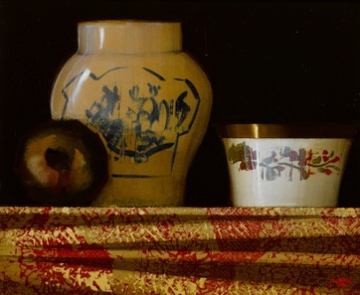

Martin Mooney

‘Still Life with Chinese Vase’

oil on panel

10" x 12”

£2800

Email: enquiries@barbarastanleygallery.uk    
Website: www.irishartinlondon.com  
T: +44 (0) 7775524414